IOP CARD- Analog (IOP-AM1)
&
Field Termination Card (FTA-AM1)

Hardware Requirement Specification
Rev-A

5-Feb-2013

Ownership Disclaimer
This document contains proprietary and confidential material that is the sole property of Compressor Controls Corporation. The information contained herein is intended for internal use by Compressor Controls Corporation employees and is not intended for distribution outside of the company. As an unpublished work of trade secrets, the recipient shall keep this document confidential. Any re-use, copying, or distribution, either in whole or in part, of this material without the express written consent of Compressor Controls Corporation is strictly forbidden.

Copyright © 2011 by Compressor Controls Corporation. All rights reserved.

Revision History

Rev. | Date | Revised By | Description
A | 5-Feb-13 | Muthuvelu. D

Approvals

Approved by: Date: _______________
Approved by: Date: _______________
Approved by: Date: _______________
Approved by: Date: _______________
Approved by: Date: _______________

TABLE OF CONTENTS

1 Introduction 5
1.1 Purpose 5
1.2 Audience 5
1.3 Scope 5
1.4 Acronyms 5
1.5 References 5
2 General Description 6
2.1 System Overview 6
2.2 Product Functions 7
2.3 Acceptance Criteria 7
2.4 IOP to FTA 8
2.5 Microcontroller Daughter Board 10
2.6 Power Architecture 11
2.7 Front Panel Indicator LEDs 12
3 Dependencies 13
4 Deliverables 14
5 Not in scope 15

TABLE OF FIGURES

Figure 1: Block Diagram of NGP System 6
Figure 2: IOP-AM1 to FTA 8
Figure 3: Block Diagram of IOP-AM1 10
Figure 4: Block Diagram of Power architecture 11

Introduction

Purpose
The purpose of this document is to capture the hardware requirements for IOP-AM1 card (I/O Analog card) and FTA-AM1 card. The IOP-AM1 board is used as I/O board for the processing analog signals interfaced to the Field Termination Card (FTA-AM1) in
New Generation Platform (NGP) control system.

Audience
This document is meant to be used by the project team members as the basis and controlling document for the design and development of IOP-AM1 and FTA-AM1 card.

Scope
The scope of this project is to design and develop the NGP boards where IOP-AM1 and FTA-AM1 board are used to process analog signals. This document defines the product requirements to which hardware has to be designed and manufactured. This document also covers system level requirements applicable to IOP-AM1 and FTA-AM1 cards. This document doesn’t cover the firmware/ software related requirements.

Acronyms
Acronym | Definition
ESC | Ethernet slave controller
NGP | Next Generation Platform
APP | Application Processor
IOP | I/O Processor

References
[1] Detailed Functional Specification for NGP Hardware, Part 1, Rev-3
[2] System Study for New Generation Platform Electronics and Bring-up, Rev-1
[3] Reference Manual of MPC5534.
[4] Vanguard Theory of Operation Healthy Logic.pdf from CCC

General Description

System Overview
New Generation Platform (NGP) is a fully redundant, duplex, highly reliable, fault tolerant control system intended to handle a number of digital, analog and frequency IOs in industrial applications.
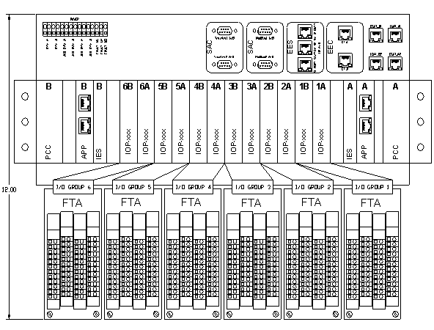 Figure 1: Block Diagram of NGP System

Here is the list of different electrical components in the system and their brief description.

IOP (Analog and Digital)
These are the processors cards which handle analog, digital and frequency IOs. There will be a maximum of 12 such cards in an NGP system.

APP
This is the main processing unit in the system. This runs the main application and does monitoring and control of the overall system. There will be a maximum of 2 such cards in an NGP system.

IES
This is the EtherCAT switch card used to interface between different APP and IOP modules. There will be a maximum of 2 such cards in an NGP system

PCC
This is power conversion card. The input power (redundant 24VDC) to the system first comes to this card. This card does the oring, filtering, protection and other voltage conversion. There will be a maximum of 2 such cards in an NGP system

CAC
These are the set of communication (Ethernet, RS-485) cards used for interface to the external devices

FTA (Analog and Digital)
These ate the field terminal cards where all the field loads are connected to. These are electrically interfaced to IOP cards. The number of FTA in an NGP system is same as the number of IOP pairs.

Backplane
All the above mentioned boards plug in backplane and communicate to each other over it.

Product Functions
IOP-AM1 card is used for processing analog signals (4 to 20 mA) from the Field Termination cards. This is based on freescale MPC5534 microcontroller.
It implements Ether-CAT master to communicate to IES card in the system.

Acceptance Criteria
Mindteck shall design, develop and deliver the hardware meeting the functionalities as detailed in this document.

IOP to FTA
The block diagram shows the communication between IOP-AM1 cards and the FTA-AM1 card. Each FTA-AM1 is accessible to two IOP-AM1 cards for realizing the duplex feature. Mainly IOP-AM1 cards process the 4 to 20 mA signals received over the backplane from the FTA-AM1 and analog outputs are switched at IOP-AM1 cards based on the health of respective boards.

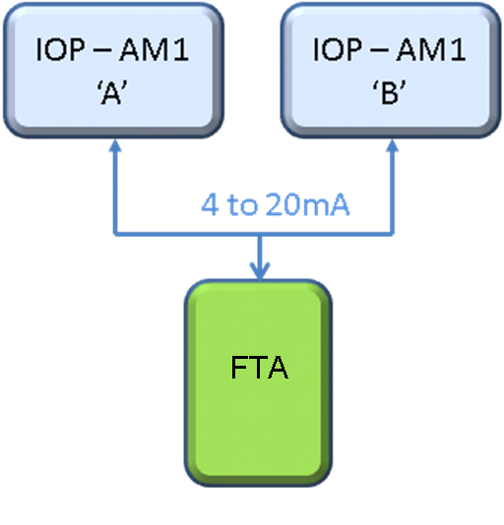

Figure 2: IOP-AM1 to FTA

FTA-AM1 card shall have the following hardware requirements on board,
Analog Inputs (12 Channels per board)
- Nine channels – Loop Powered only.
- Three channels - External OR Loop powered options.
- Three channels - 4-20 mA, or 1-5V, switchable at the FTA w/ 250ohm resistor

IOP-AM1 card shall have the following hardware requirements on board

- Freescale processor MPC5534 based design(Daughter board).
- Ether-CAT (ET1100) bus communications.
- Supports general board diagnostics (Voltage, temperature)
- Hot-swap and load sharing capability
- Development / test port facility (JTAG, Nexus, logic analyzer etc)

- Analog Inputs (12 No’s)

- Isolated to each others.
- Resolution: 16-bit minimum
- Accuracy (0.1%)
- SPI EEPROM for calibration data
- Indication LED’S
- Ability to extract HART information from all signals and provide to external systems

- Analog Outputs (4 No’s)

- Isolated to each others.
- Resolution: 16bit minimum
- Accuracy (0.1% minimum)
- Verification/Diagnostics of card functionality
- Ability to extract HART information from all signals and provide to external systems
- Duplex Switching
- Indication LED’S
- Ability to extract HART information from all signals and provide to external systems

Freescale
MPC5534
Microcontroller
Backplane Connector
Flash
LEDs
ET1100/ ET1200
Voltage Monitoring/ Reset
Hardware Watchdog Timer
Debug Port
Temperature Monitoring
DC-DC
Regulator
Hot Swap
Control
EBUS
SPI
Analog Output (4-20mA)
(4)
NVSRAM
Analog Input (4-20mA,1-5V)
(12)
PLD
HART
EEPROM

Figure 3: Block Diagram of IOP-AM1

Microcontroller Daughter Board
- Freescale MPC5534 microcontroller shall be implemented as main processing unit.
- Memory details

Make | Part No | Description
Cypress | CY7C1051DV33-10BAXI | SRAM- 512K x16
Ever spin | MR4A16BCMA35 | MRAM- 1Mx16
Spansion | S29AL008J70BFI02 | NOR FLASH – 512K x16

Power Architecture

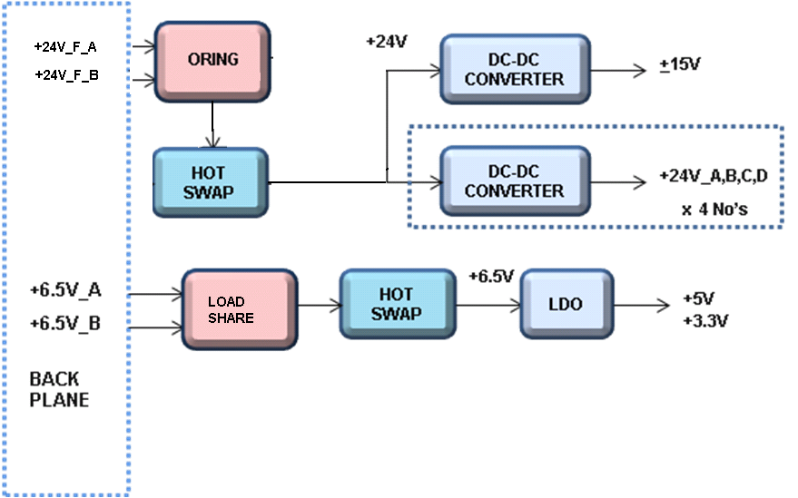

Figure 4: Block Diagram of Power architecture

- Both 24V_F and +6.5V A and B power supplies are hot swappable.
- Enabled through short pin (AirMax connectors).
- +24V is used for generating +15V for ADC section (analog inputs) and 4 No’s of isolated 24V_A, B, C, D are generated (analog outputs).
- +5V and +3.3V (Digital Supplies) are generated from +6.5V LDO.

Front Panel Indicator LEDs

Name | Controlled By
CCC LOGO | HW
ACTIVE | SW
READY | SW
ALARM | SW
FAULT | SW
CPU | SW
LEARN | SW
ETHER1-LINK | HW
ETHER1-RUN | HW
ETHER2-LINK | HW
ETHER2-RUN | HW
IN1 | SW
IN2 | SW
IN3 | SW
IN4 | SW
IN5 | SW
IN6 | SW
IN7 | SW
IN8 | SW
IN9 | SW
IN10 | SW
IN11 | SW
IN12 | SW
OUT1 | SW
OUT2 | SW
OUT3 | SW
OUT4 | SW

Dependencies
- Finalization of all components and connectors shall be approved by CCC.
- Mechanical enclosure, Board dimensions shall be approved by CCC.
- CCC shall ensure availability of about 10% time from an CCC’s representative for addressing queries, reviews and acceptance
- Timely inputs, reviews and approvals
- Assistance in the finalization of all the requirements specification documents
- Validation testing and approval of prototypes

Deliverables

Mindteck shall deliver the following hardware deliverables as per the project plan for CCC review and acceptance…

- Hardware Requirements Specifications document
- Hardware Design Document
- Schematics design files (PADS Logic)
- Board Layout files (PADS Layout) & Gerber files
- Bill of Materials
- Tested prototypes
- Test reports

Not in scope

- User manual, tutorial or any other user documentation
- Certification, environmental, ATEX testing, EMI/EMC testing
- Mechanical / enclosure design or prototyping and assembly

